**SEO Strategy for CODTECH**

# **Introduction:**

The digital solutions company CODTECH delivers web development together with mobile app development and offers services for UI/UX design in combination with digital marketing. Organizations need comprehensive search engine optimization strategies to increase their online presence which enables them to capture quality leads more successfully than competition. This document outlines CODTECH's SEO strategy focusing on Keyword Strategy, Backlink Building, and Technical SEO, along with a practical implementation checklist.

## **SEO Objectives**

* Improve website ranking for target keywords
* Increase organic traffic
* Reduce bounce rate and improve user engagement

## Keyword Strategy

**Keyword Research Approach**

* **Use tools:** Google Keyword Planner, SEMrush, Ahrefs, Ubersuggest
* **Focus on:**
  + High-volume, low-competition keywords
  + Long-tail keywords for niche targeting
  + Buyer intent keywords (commercial and transactional)

**Targeted Keyword Categories**

* **Primary Keywords:** web development company, mobile app development, digital marketing agency, UI/UX design services
* **Secondary Keywords:** affordable web development, top app developers India, SEO services for startups, custom web solutions
* **Local SEO Keywords:** digital marketing agency in Pune, app development company near me

**Content Types for SEO**

* Blog posts (industry trends, how-to guides, case studies)
* Landing pages for services
* FAQs and glossary
* Testimonials and case studies

# **Backlink Building Strategy**

**Goals**

* Improve domain authority
* Gain relevant traffic
* Build credibility

**Methods of Link Building**

* **Guest Blogging:** Submit content to relevant industry blogs and link back to CODTECH
* **Business Listings:** Register CODTECH on Google My Business, Clutch, GoodFirms, etc.
* **Content Outreach:** Share high-value content with influencers and bloggers
* **Broken Link Building:** Find broken links on other sites and offer CODTECH's links as replacements
* **Social Sharing:** Promote content on LinkedIn, Twitter, Medium, and Quora

**Tools for Monitoring**

* Ahrefs
* Moz
* SEMrush

# **Technical SEO Strategy**

## Mobile Optimization

* Ensure mobile-responsive design
* Use mobile-friendly test tools

## Crawlability and Indexing

* Submit updated XML sitemap to Google Search Console
* Create and optimize robots.txt
* Fix crawl errors

## Content Mapping

* Homepage → Primary + Local Keywords
* Services Pages → Long-Tail + Secondary Keywords
* Blog → Informational and trending tech keywords (e.g., “Top 10 app development frameworks 2025”)

# Top 15 Targeted SEO Keywords for CODTECH

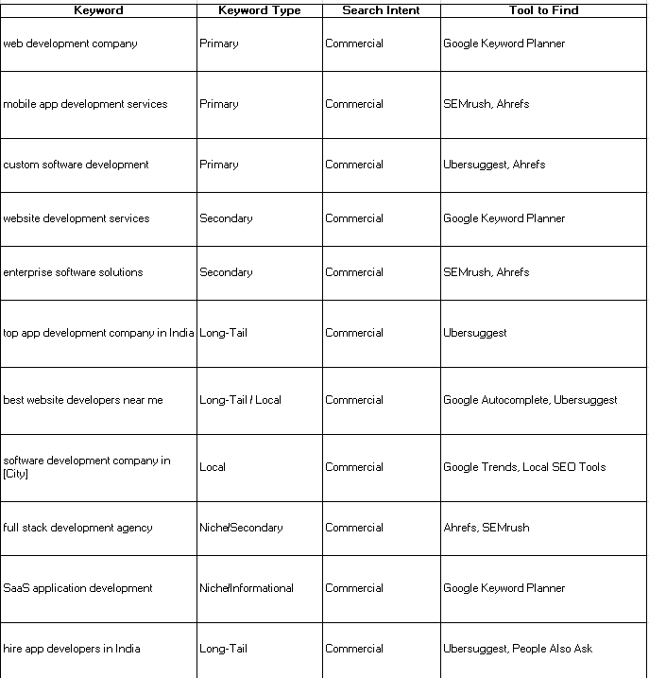

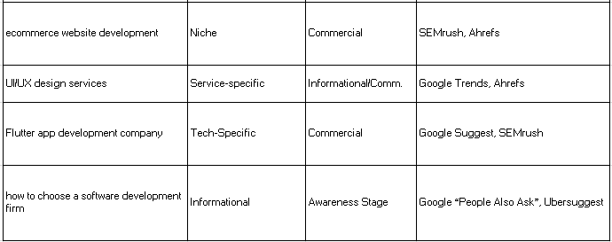

# SEO Checklist

* Find and pick the right keywords
* Add keywords naturally in titles and text
* Make sure the website loads fast
* Make sure the website works well on mobile
* Install SSL (secure the site)
* Submit a sitemap to Google
* Share posts on social media
* Get backlinks by helping others and sharing good stuff
* Fix any broken links
* Set up redirects for old pages

**SEO is not something that shows results overnight — it is like planting seeds in a garden. If we stay consistent — creating useful content, improving the website, and building good relationships — our site will grow and rank higher over time.**